5.7 Divergence Theorem

In this section we introduce a new idea related to vector fields and a related application.

Definition: If is a vector field on and , , and exist, then the divergence of F is the function of three variables defined by .
Symbolically one may write .

Remark: To help ourselves in remembering the formula for divergence, we introduce the differential operator (“del”): . Then, we can think of the divergence of F in the following way: .

Example 1: Consider the vector field . Find .

Application: In the context of fluid flow, if F is the velocity of a fluid, then represents the net rate of change (with respect to time) of the mass of fluid flowing from a point per unit volume. In other words, is the extent to which there is more exiting an infinitesimal region of space than entering it.

Example 2: Let . Determine which points are considered sources, sinks, and neither.

Recall:
Green’s Theorem relates the line integral of a vector field over a closed curve in 2-D to a double integral taken over the region enclosed by the curve. There are two natural ways one might try to generalize Green’s Theorem which we now state.

- We might try to increase the “dimensions of the integrals” in Green’s Theorem by one. More precisely, we might guess that the flux of a vector field through a closed surface is equal to a triple integral taken over the region enclosed by the surface.

- Alternatively, if we have a closed curve in 3-space (rather than 2-space), we might guess that the line integral of a vector field over the curve is equal to a surface integral taken over the region that the curve encloses.

The first idea for a generalization of Green’s Theorem leads to the Divergence Theorem which is the focus of this section, and the second idea for a generalization of Green’s Theorem leads to Stokes’ Theorem which is covered in section 5.8.

So, in this section, we are interested in asking;

To answer this question, suppose that C is given by where . Then the unit tangent vector to C at t is . From this it is fairly easy to see that: .

So, we have that

Theorem (The Divergence Theorem):
Let G be a solid whose surface is oriented outward. If F is a vector field whose component functions have continuous partial derivatives on an open region that contains G, and if n is the outward unit normal on , then

Note: Recall that positive orientation of a solid is outward.
Note: If has inward orientation then it would be the case that .

Proof: See pages 1149-1151 for an outline of the proof. We will not go over the proof in class since it is a natural generalization of the proof of Green’s theorem that we went through earlier.

Note: The Divergence Theorem says the flux of F across the boundary of G is a triple integral over G. Notice the theme in Green’s Theorem & The Divergence Theorem is that some integral over a region is equal to another integral taken over the boundary of the region.
Example 3: Find the flux of the vector field across the unit sphere: with positive orientation.

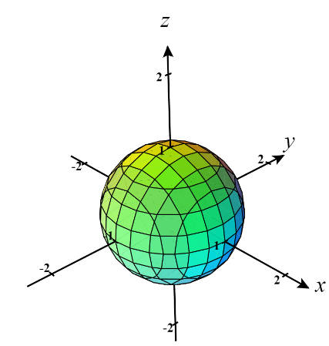

Example 4: Suppose that is the surface given by that exists below . Kyle tries to find the flux of across with respect to downward normals by using the Divergence Theorem but his teacher tells him that he can’t do this. Why doesn’t the Divergence Theorem apply here?

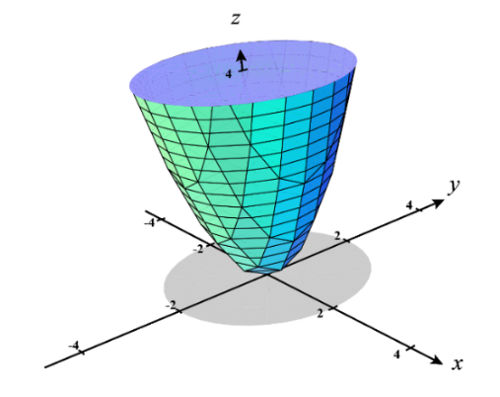

Example 5: Suppose that is the surface that bounds the region enclosed by and . Find the flux of across with respect to outward normals.


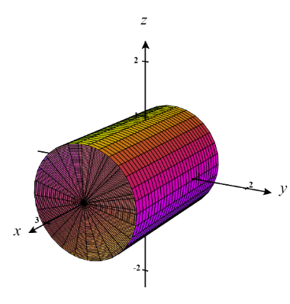
Example 6: Find the flux of F across where and is the surface with outward orientation shown below that bounds a solid region G using the cylinder and the planes and .

- Complete this question by using the Divergence Theorem.

- Setup, but do not evaluate, integrals which represent this flux by computing the flux directly.


Fact: The Divergence Theorem also holds for regions that are the finite union of simple solid regions.

Note: Proving this fact is similar to proving that Green’s Theorem holds for regions with holes.

Example 7: Suppose the surface is made up of two separate surfaces represent a unit cube and unit sphere (as shown in the image below). Show how the Divergence Theorem can be used to find the flux of across with positive orientation.
